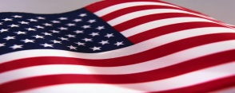
Winona Lake
Great 4th of July Celebration

Judges Choice

1.

2.

3.

Most Creative

1.

2.

3.

Most Original

1.

2.

3.

Best Theme

1.

2.

3.

